**DATA LITERACY WITH TABLEAU**

**UNLOCKING INSIGHTS INTO GLOBAL AIR TRANSPORTATION NETWOK**

**A**

**PROJECT REPORT**

**SUBMITTED BY**

**ALAGAPPA UNIVERSITY, KARAIKUDI**

**THROUGH**



**UNDER**



**Submitted by**

**M.Shalini (Team leader ),**

**S.Sowndhariya,**

**S.Sreena Suki,**

**R.Sumithira.**

**From the**

1. **DEPRTMENT OF PHYSICS ( 3rd UG)**

**IDHAYA COLLEGE FO WOMEN ,SARUGANI ,SIVAGANGA –DT.**

**1.INTRODUCTION**

**Overview** : This Global Air Transportation Network dataset is a comprehensive collection of information on airports, airlines and their routes. It contains information such as names, cities, countries, codes (IATA and ICAO) longitudes, latitudes and altitudes of airports across the world with detailed time zone and daylight saving time data. Additionally, this includes information about airlines including their IDs, name aliases, IATA and ICAO codes, callsigns country of origin and active/inactive status.

**Technical Architecture:**



**2. Problem Definition & Design Thinking**

The team members ideas are grouped by Empathy Map and Ideation & Brainstorming Map using app.mural.com

Here we done the following

➢ Defining the problem

➢ Problem understanding ➢ Specification of the business problem

**EMPATHY MAP:**

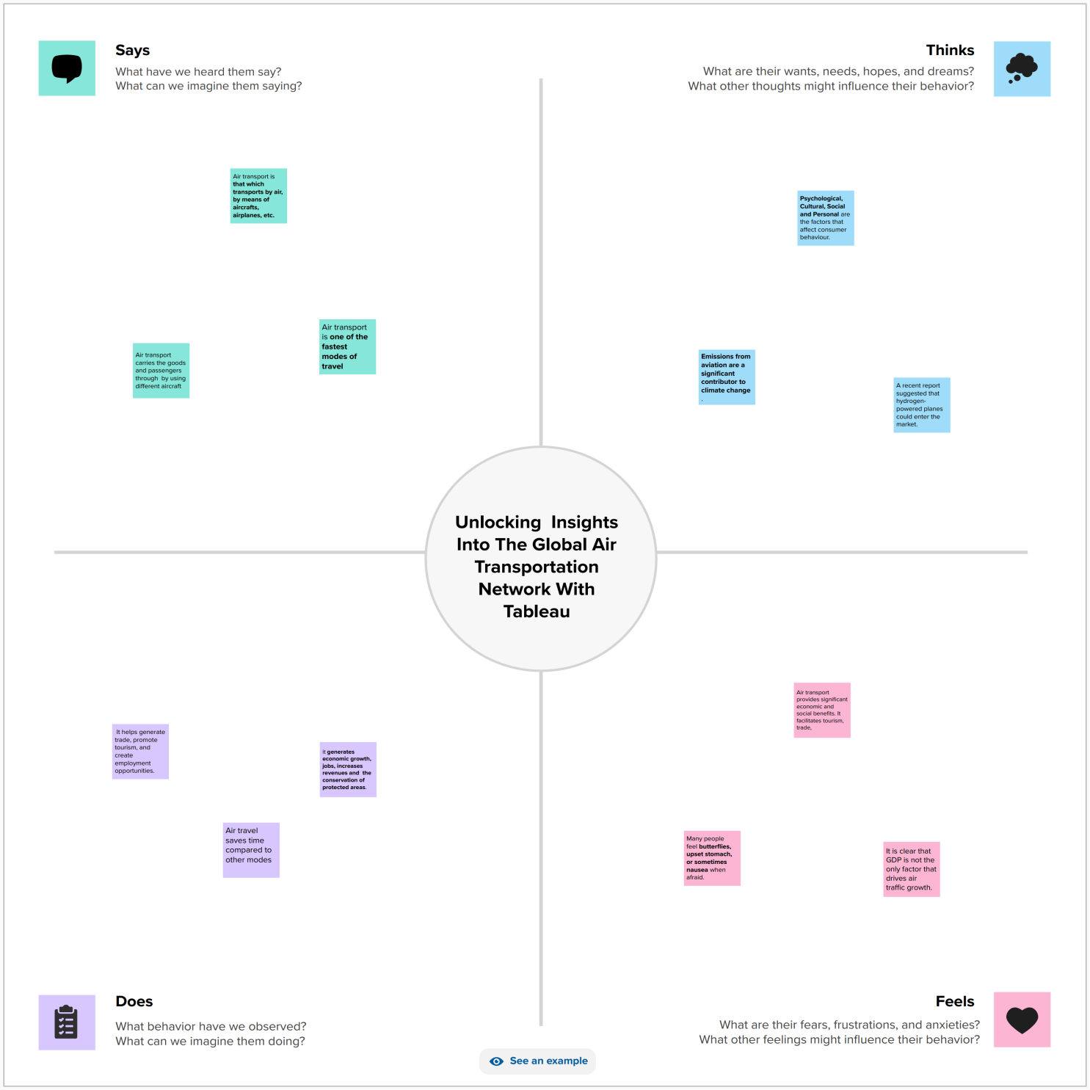

**IDEATION AND BRAINSTORMING MAP :**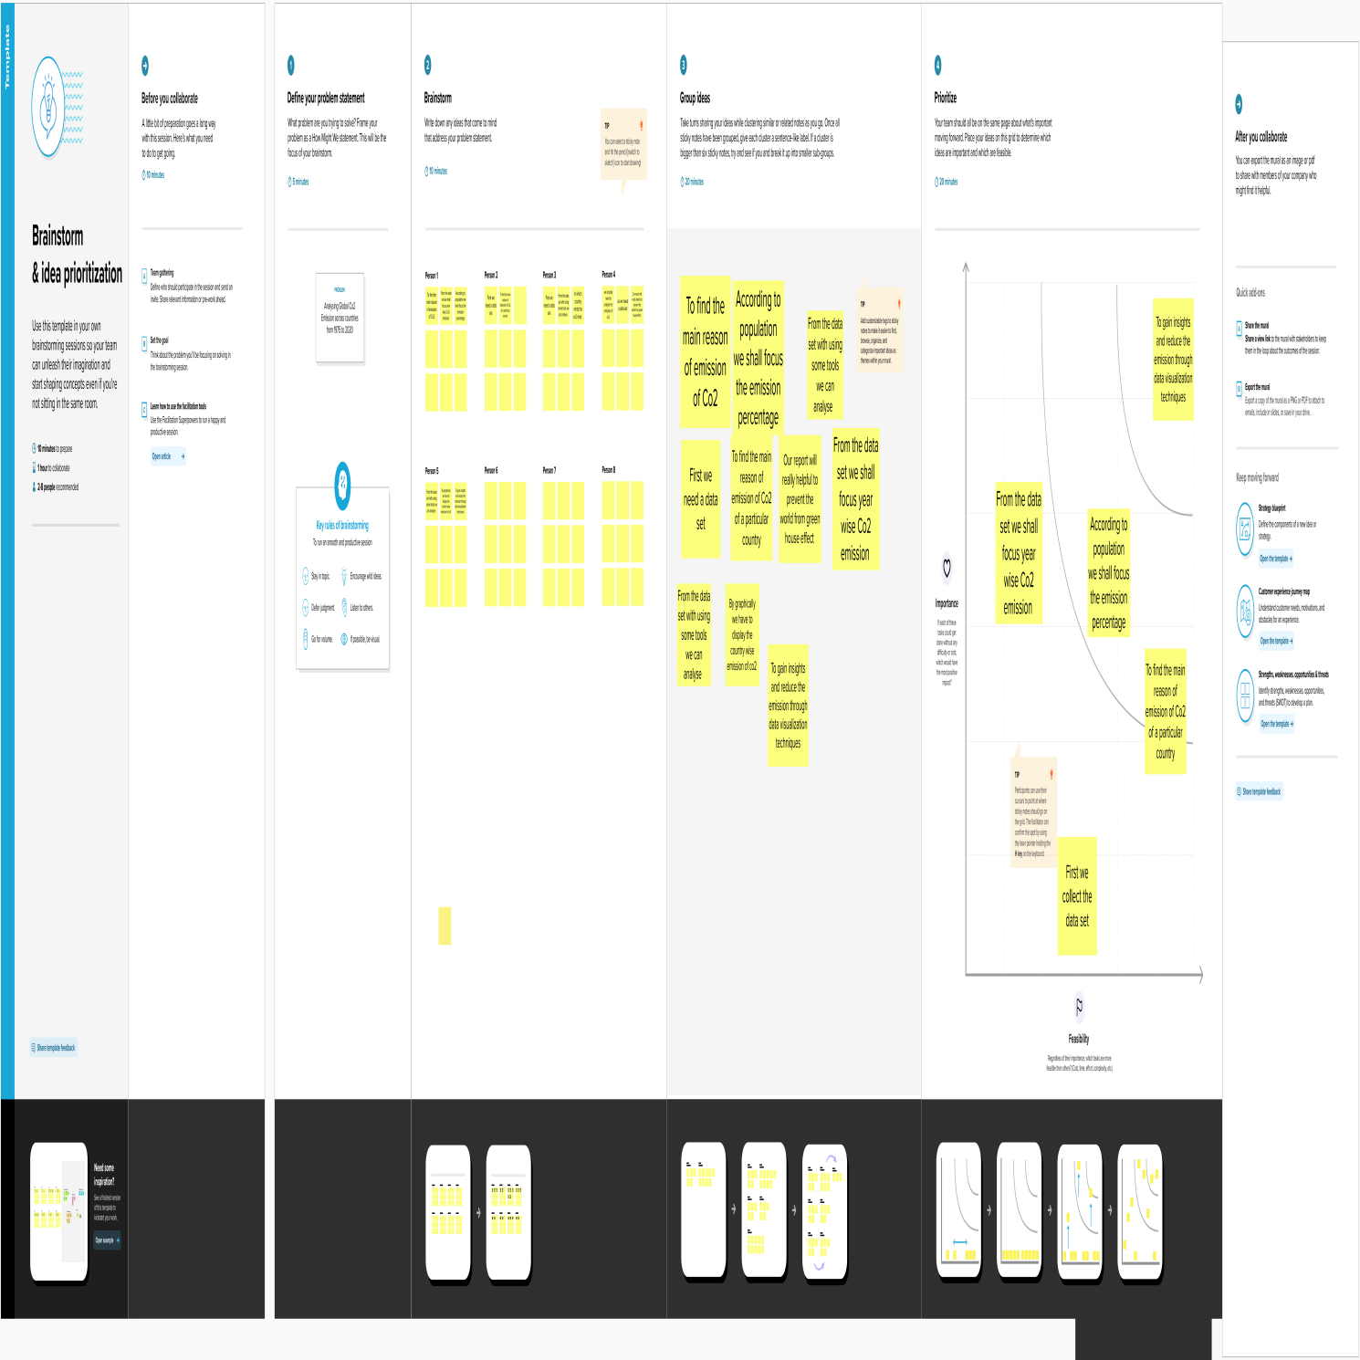

**3. RESULT**

One of the main advantages of Tableau is its easy to use. We

don't need to have any coding or programming skills to create stunning and informative dashboards, charts, maps, and stories with Tableau. You can simply drag and drop data sources, fields, filters, and visual elements to customize your views and analysis. Once you have created views on different sheets in Tableau, you can pull them into a dashboard.

**These are screenshots of our project work.**

1. **Screenshots of Sheets**

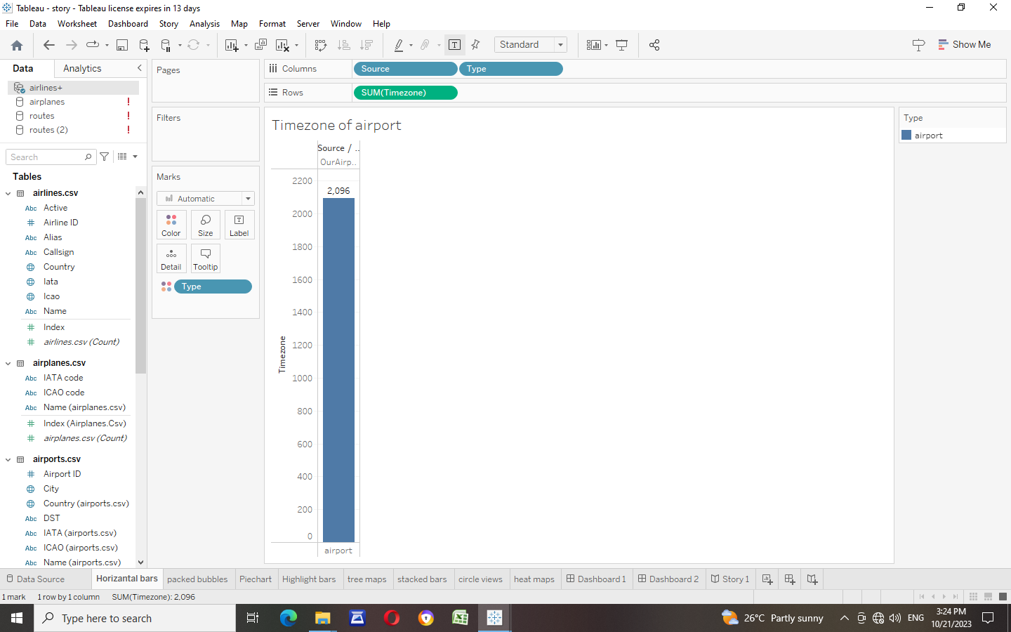

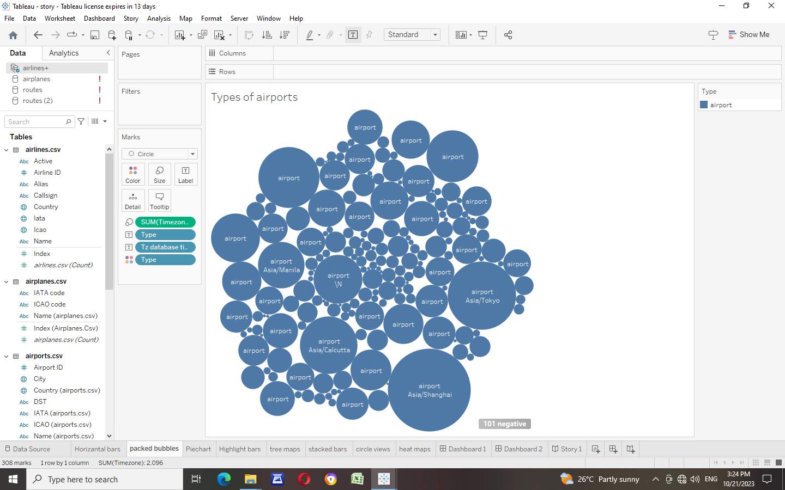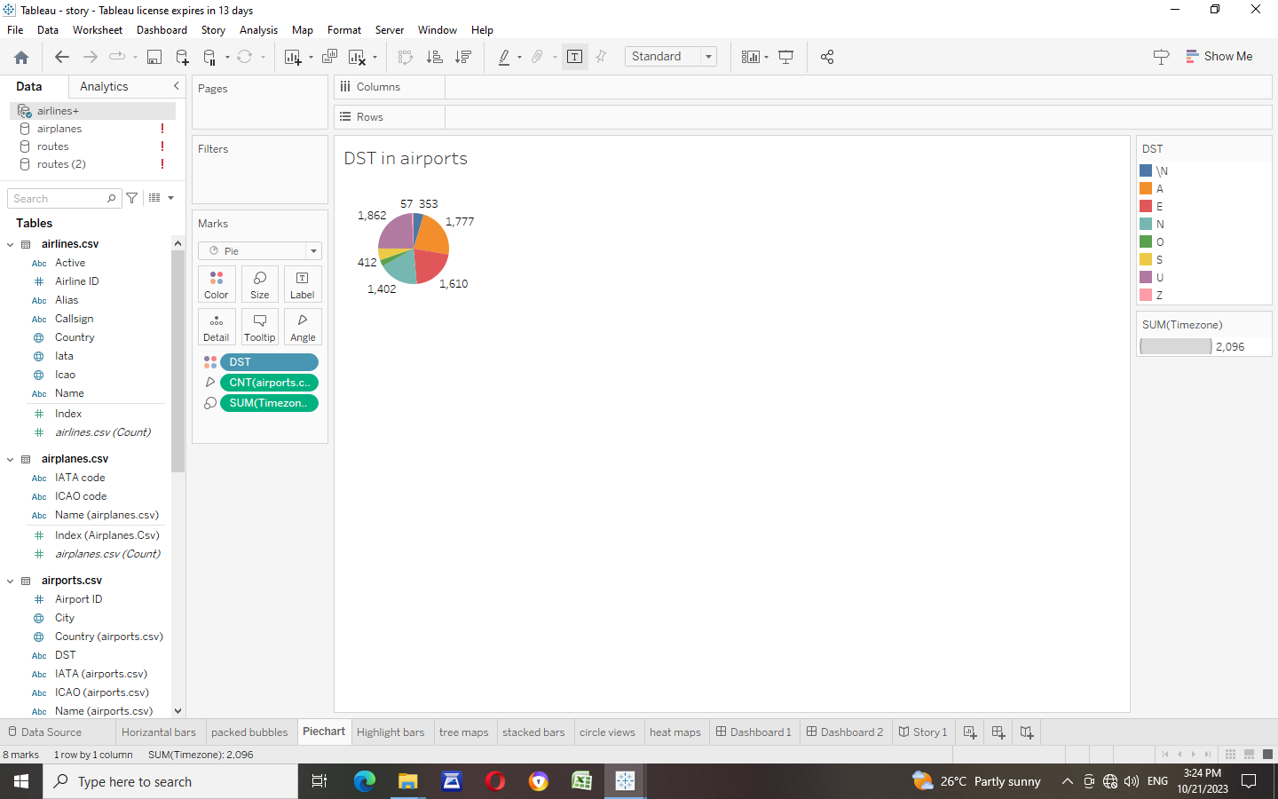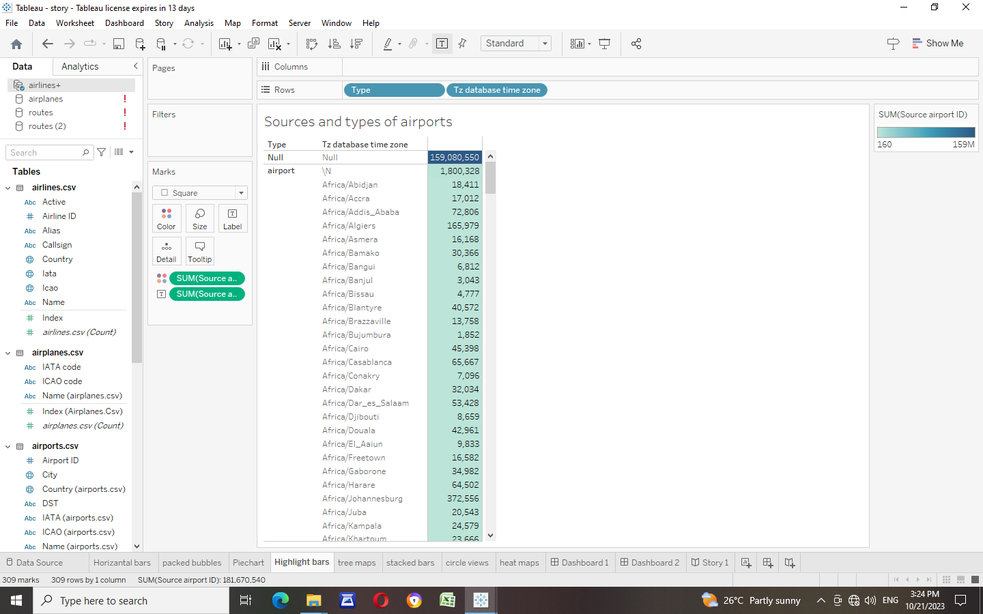 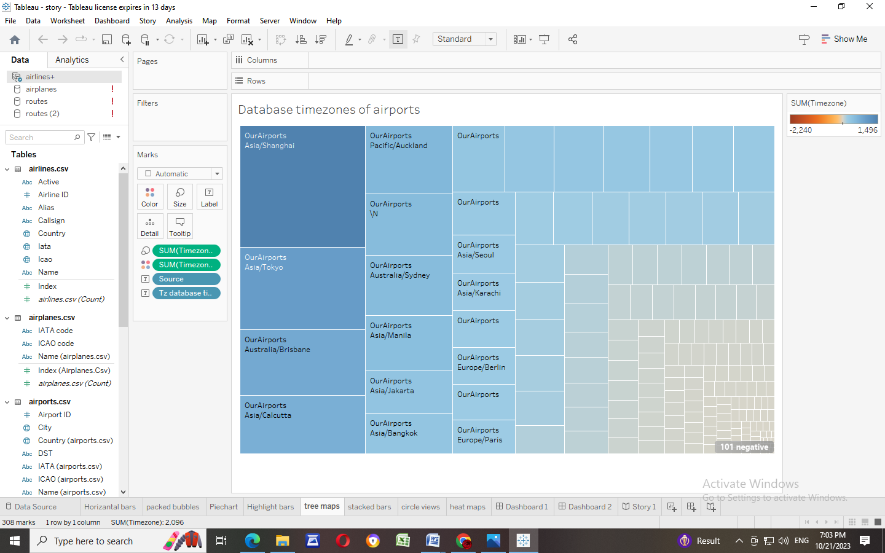 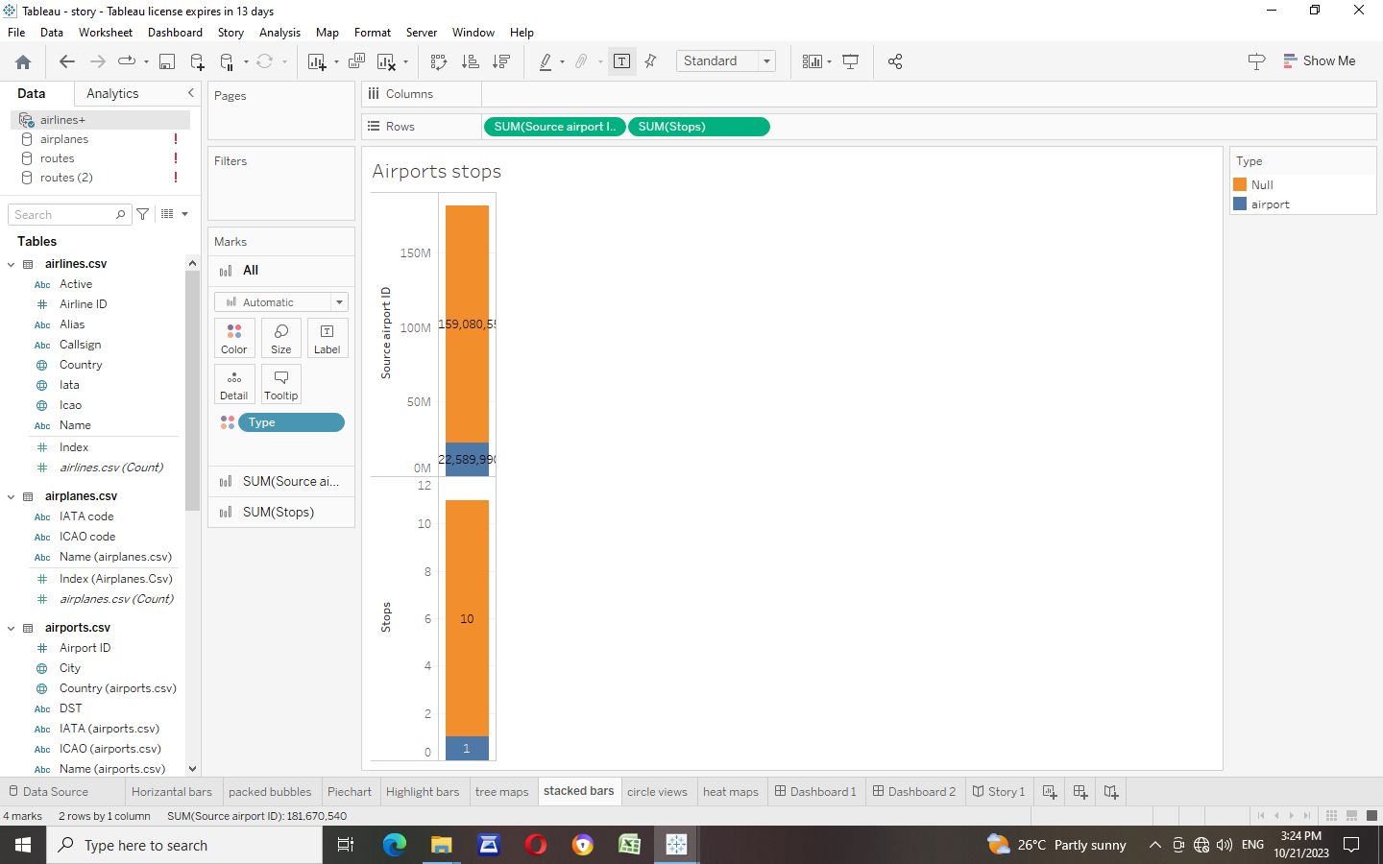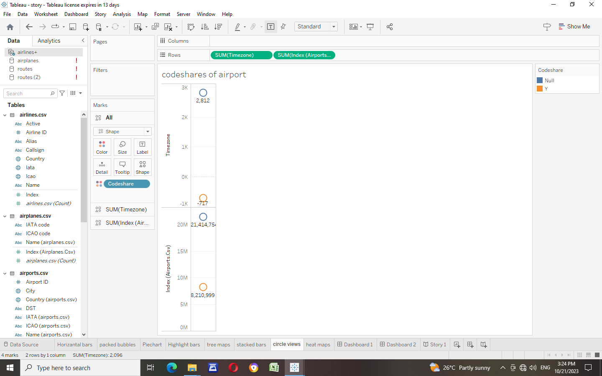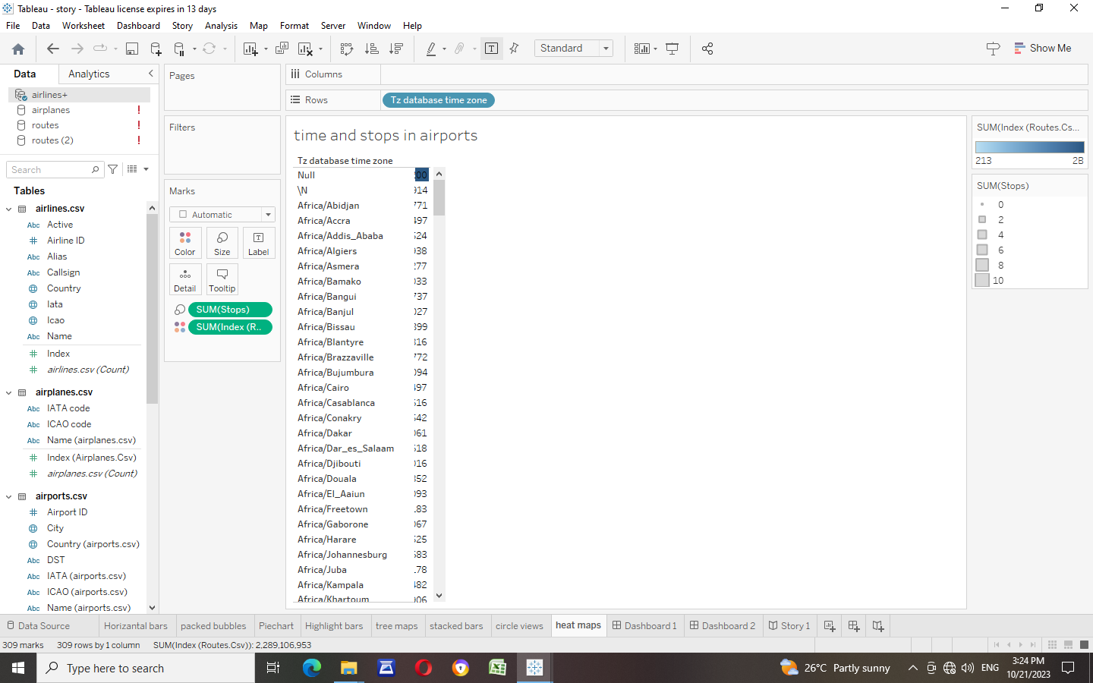

1. **Screenshots of Dashboards**

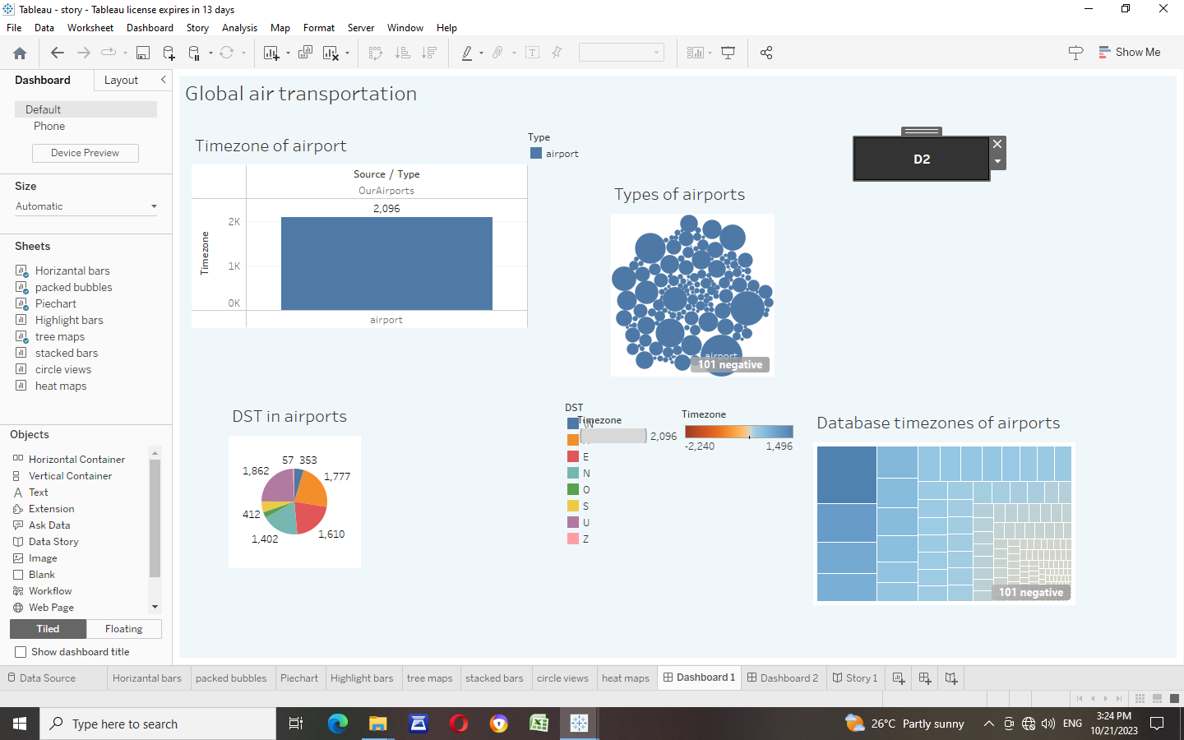

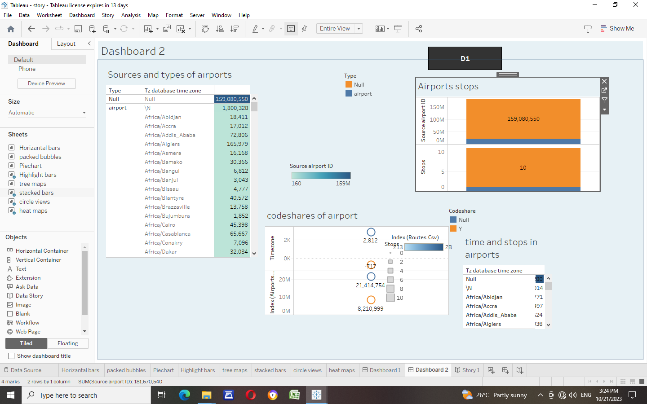

1. **Screenshots of Stories**

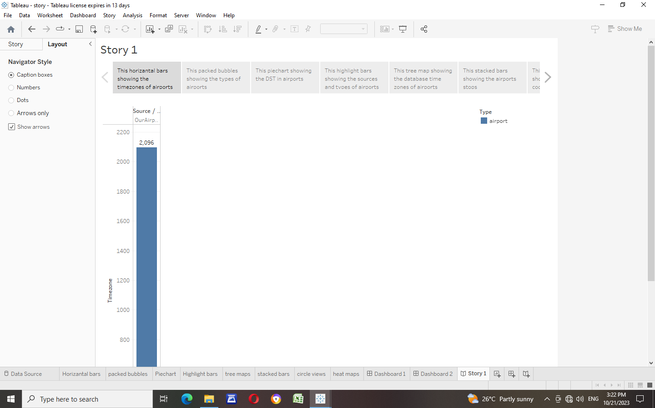

1. **Screenshots of Published Work**

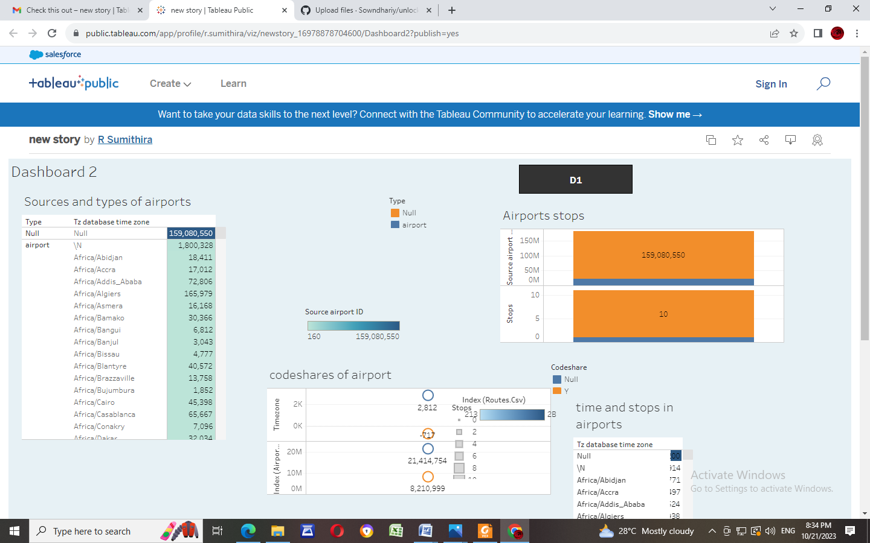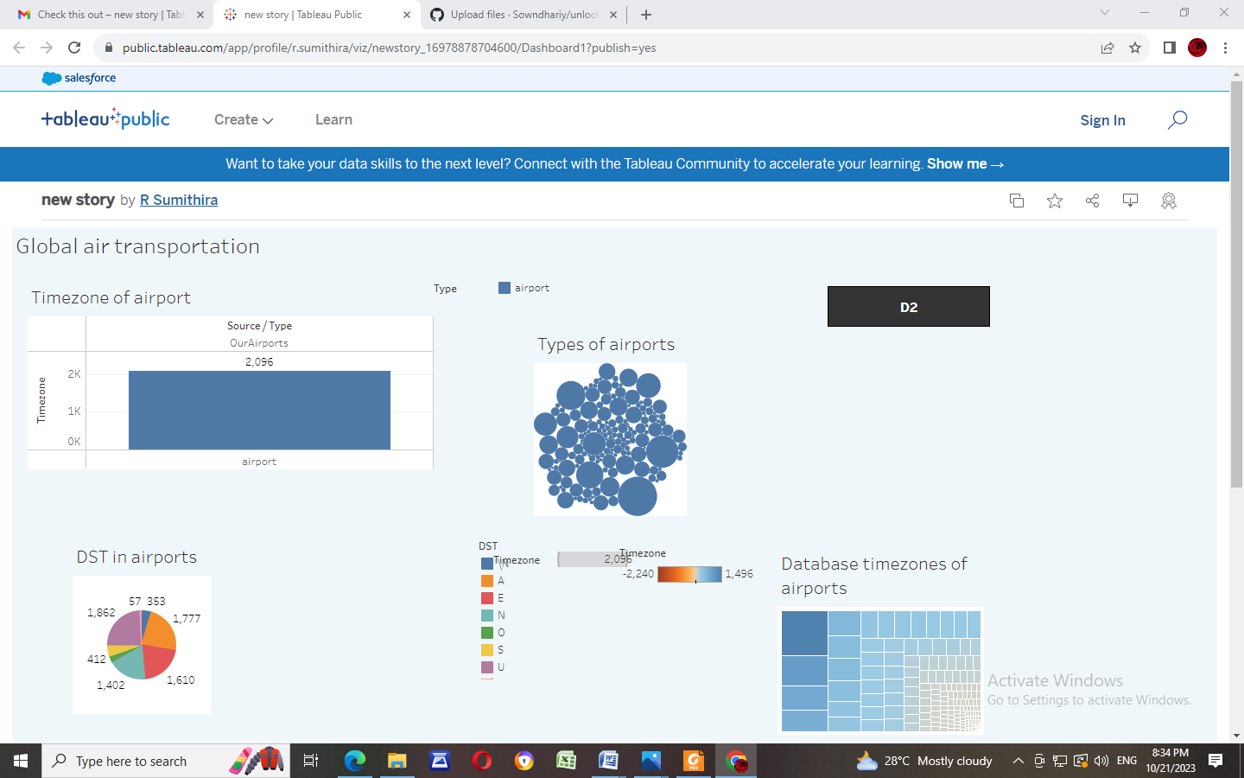

**ADVANTAGES AND DISADVANTAGES**:

* Undoubtedly, one of the most advantageous features offered by air transport is its **speedy delivery times.**
* Air transport is the only means of transportation that **does not support physical limits**.
* One of the great advantages of air transport for both passengers and goods is its great **reliability**.

T

* The cost of infrastructure, fuel… makes air transport economically superior to other alternatives.
* Storage capacity is lower than land and sea transport.

**APPLICATIONS**

**1 Mobile-Friendly**

**2.Informative Dashboards**

**3.Advanced Visualization Capabilities**

**4.Availability of Maps. And so on.**

**CONCLUSION:**

Air transport is an important enabler to achieving economic growth and development. Air transport facilitates integration into the global economy and provides vital connectivity on a national, regional, and international scale. It helps generate trade, promote tourism, and create employment opportunities.So the maps , charts, story and dashboards will help us to understand a lot about airlines and airports.